Comparison between processing of noisy inputs in dendritic subunits and whole-cell synaptic integration described in ‘Dendritic spikes expand the range of well-tolerated population noise structures” <https://www.jneurosci.org/content/early/2019/09/26/JNEUROSCI.0638-19.2019/tab-e-letters>.

Simulated cortical cells (pyramidal layer 2/3 or pyramidal layer 5) are assumed to be innervated by inputs from a presynaptic population that increases its firing rate when presented with a preferred stimulus. In the focal synaptic distribution active synapses on the postsynaptic cell are mapped to an individual dendritic branch in layer 2/3 simulation or 5 branches in the case of a layer 5 cell. In the global synaptic distribution all synapses are placed randomly across the dendritic arbor.

The simulation includes population noise, which modifies the number of spikes elicited by each presynaptic cell. There are two main noise structures in the simulation. The first noise samples from a Gaussian distribution (noise intensity if set by Fano factor (variance/mean); set by the ‘stochastic noise’ variable). The second noise structure introduces classification errors. In the case of classification errors (%) the stimulus is assumed to represent a binary choice (preferred/null) and a small percentage of inputs respond to the opposite stimulus. With classification errors (degrees, DS) the input population is assumed to encode stimulus direction and the trial-trial variability arises from shifts in the encoded direction. In this scenario, the classification error represents the width of a normal distribution of input directions that is sampled by the cells in the population. In the case of only two possible directions, directional classification errors are equivalent to the binary choice classification errors.

Figure 1: Top, example focal activation of 8 synapses on a dendrite of a layer 2/3 cell (black, soma; grey, active dendrite) during the preferred (left) and null (right) stimuli. Bottom, 10 superimposed traces of responses to the preferred (left) and null (right) stimuli.

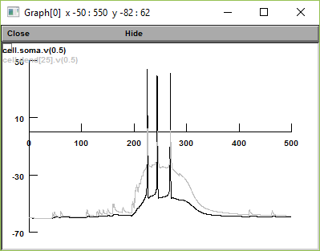 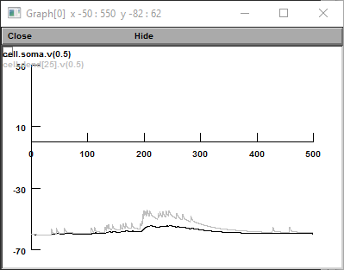

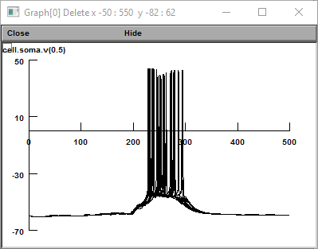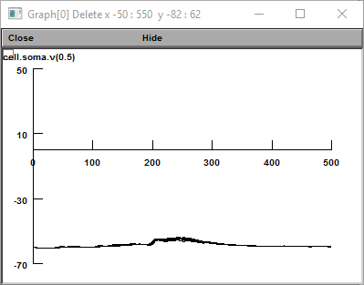

Figure 2: Example focal activation of 200 of passive (AMPA only) synapses on a layer 2/3 cell (black, soma; grey, same dendrite as on Figure 1) in the preferred (left) and null (right) directions

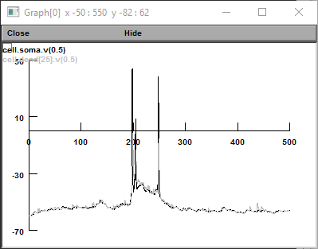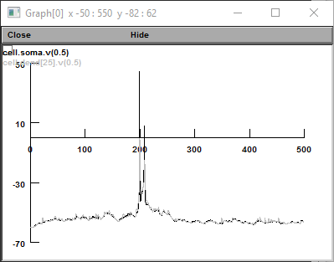

Figure 3: Stochastic (Gaussian) variability in the presynaptic population (Stochastic noise was set to 1.5). Top, dendritic focal stimulation, boron, global activation. Left – Preferred, right-null stimuli. Note the errors in postsynaptic responses following dendritic subunit activation that are evident from spiking to null and no spiking to preferred stimuli.

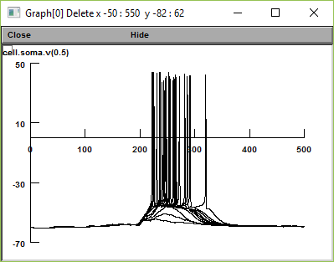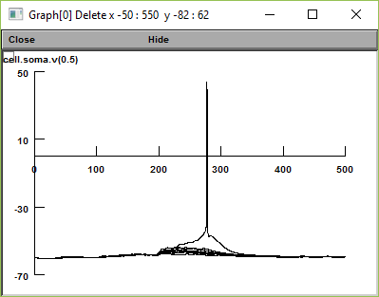

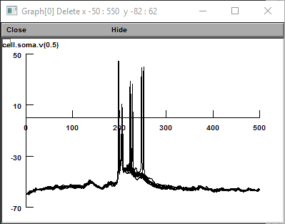 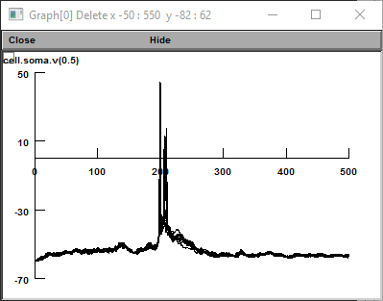

Figure 4: Same as Fig. 3 with classification errors (15%) produce accurate responses in the dendritic units (top) but lead to significant decrease in the number of action potentials elicited for the preferred direction (bottom left) and some increase in the number of spikes to the null stimulation (bottom, right) for global synaptic distribution.

